Criteria for Success
CP | Honor
- C: 1 correct answer for each lesson  - B: 2 correct answers for each lesson  - A: 3 correct answers for each lesson | - C: 2 or some correct answers for each lesson  - B: 3 or many correct answers for each lesson  - A: 4 or all correct answers for each lesson
**”Take It Further” problems count as two problems.

5.15
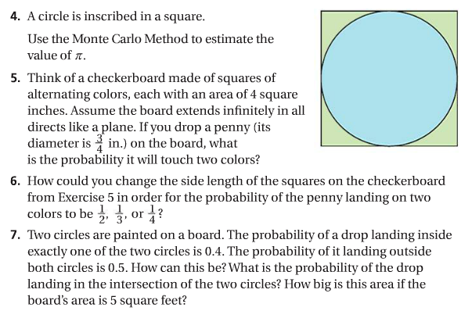
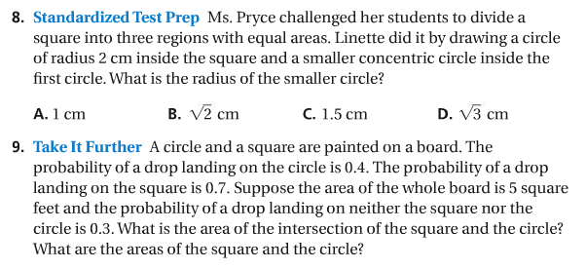

5.16
