Criteria for Success
CP | Honor
- C: 1 correct answer for each lesson  - B: 2 correct answer for each lesson  - A: 3 correct answer for each lesson | - C: 3 or some correct answer for each lesson  - B: 4 or many correct answer for each lesson  - A: 5 or all correct answer for each lesson
**”Take It Further” problems count as two problems.
5.05
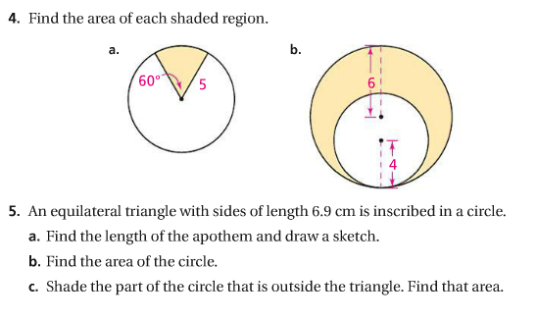
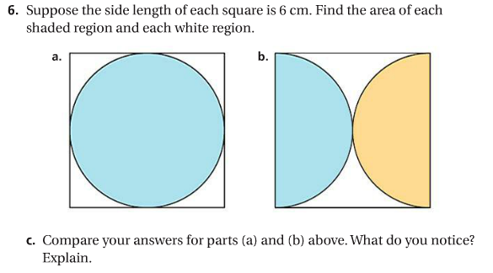
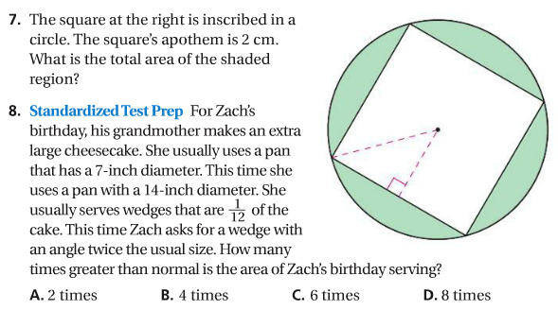
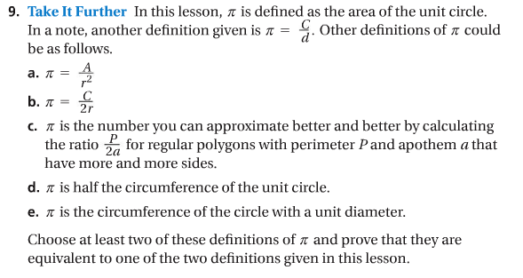

5.06
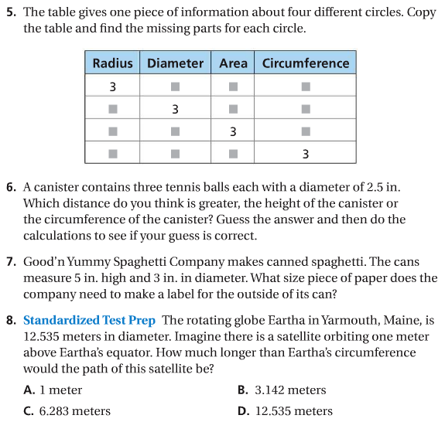
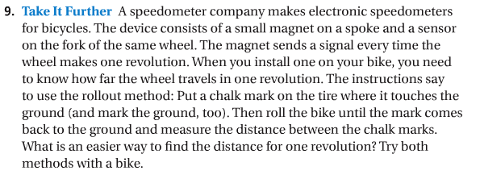

5.07
