Criteria for Success
CP | Honor
- C: 1 correct answer for each lesson  - B: 2 correct answers for each lesson  - A: 3 correct answers for each lesson | - C: 3 or some correct answers for each lesson  - B: 4 or many correct answers for each lesson  - A: 5 or all correct answers for each lesson
**”Take It Further” problems count as two problems**
5.02
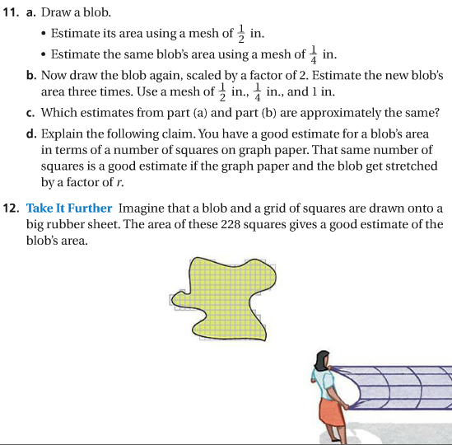
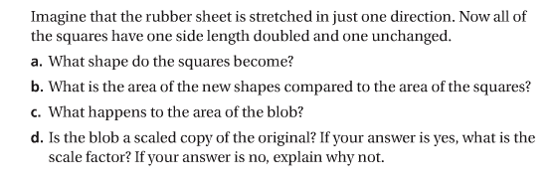
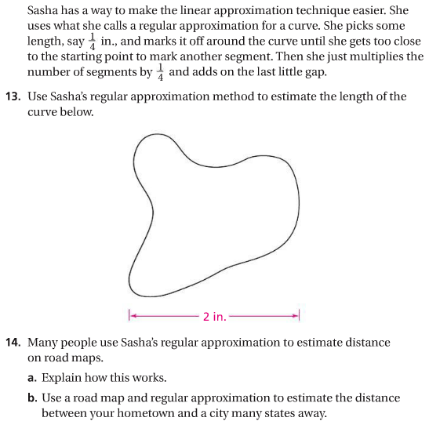
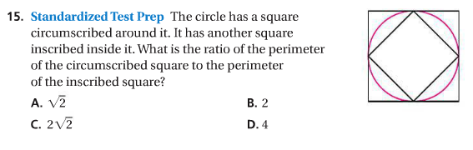

5.03
